UCANDAS Wireless Automotive Diagnosis System
- Product introduction
The state-of-art UCANDAS® is delicately engineered and built by P&T Electronic Technology Co., a scan tool R&D company based in China. Established in 2009, P&T is now recognized by the automotive aftermarket industry as one of the fastest growing scan tool companies providing the most extensive and best price-performance ratio OEM-level diagnostic products and first-class customer support in the world. The UCANDAS® Diagnostic System is ingeniously designed to recreate the functionality of the OEM tools used by automotive manufacturers’ dealers, empowering independent garage shops to provide complete servicing in their own shops, including data stream, reading and clearing of diagnostic trouble codes, component activation and immobilizer key coding, etc.

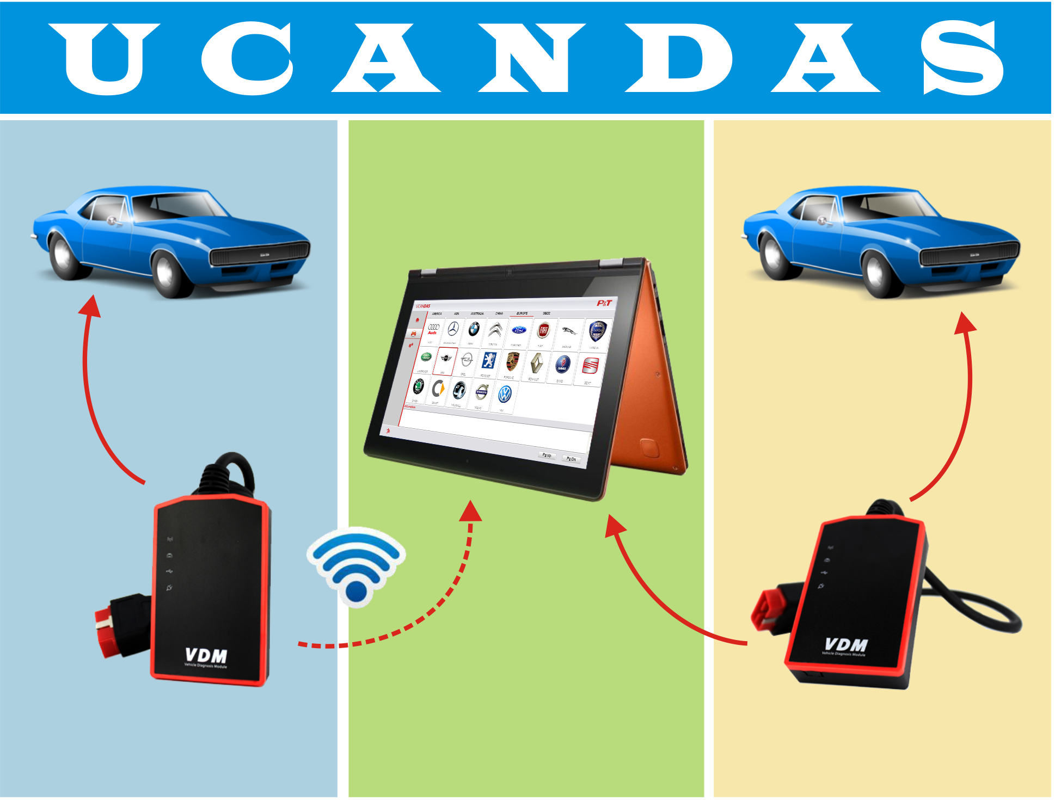

- Product features

- Supporting ISO 9141-2, K/L line, SAE-J1850 VPW, SAE-J1850 PWM, CAN ISO 11898, ISO15765-4 protocols.
- High-speed, medium speed and low speed CAN-BUS, Single CAN-BUS diagnosis protocols is supported.
- Can check out the year and model of the vehicles automatically and quickly.
- All inclusive software coverage - European, American, Asian and Australian prevalent vehicles.
- OBDII diagnostic connector has a wide compatibility, which don’t need to replace other connector, during the testing.
- Hardware architecture uses new design with multiple protection, interference and stability. Built-in overvoltage protection module is applied, in order to protect scanner and vehicle against accidental damage during checking.
- Can work stably in high and low temperature environment, and work well.
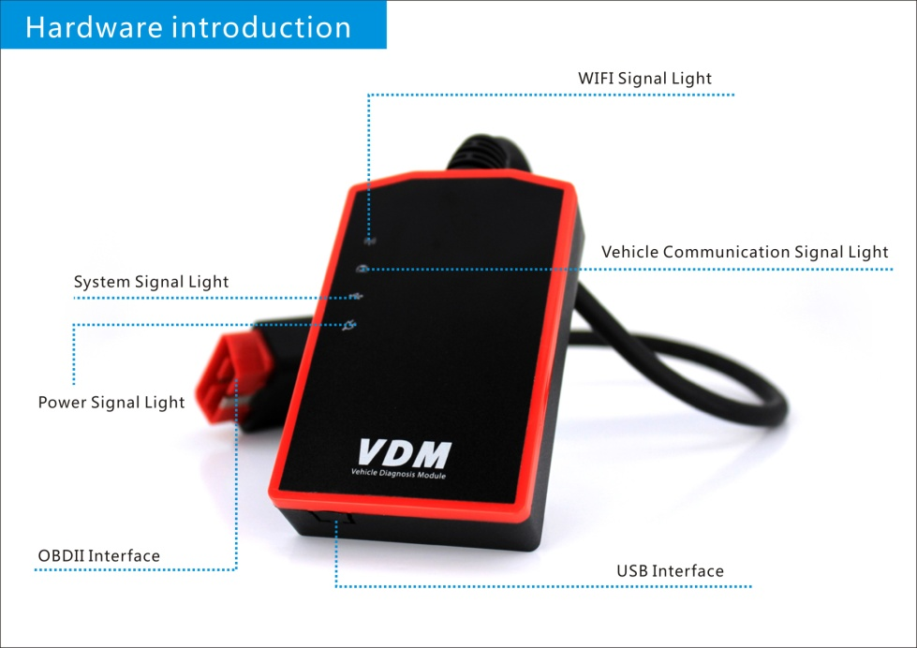

- Specifications
MCU: ARM7 processor, 66MHz
Input Voltage: DC 8-18V
Communication Mode: USB and WIFI
Storage Temperature: -30 to 120 ºC(-22 to 248 ºF), Relative Humidity: <90%
Operating Temperature: -30 to 120 ºC(-22 to 248 ºF), Relative Humidity: <90%
Dimension: 137mm*175mm*63mm
Unit Weight: 250g (GW)

- Operation guiding：

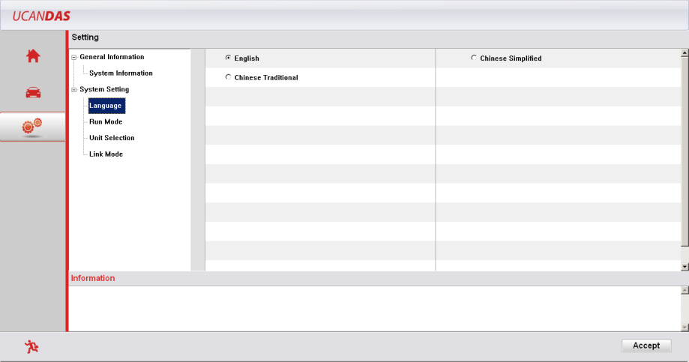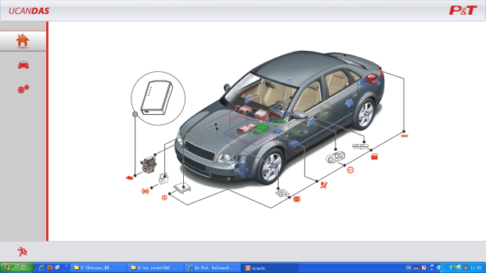
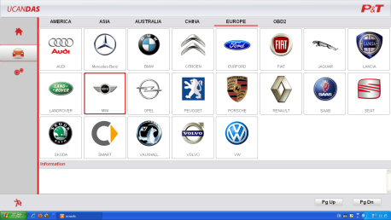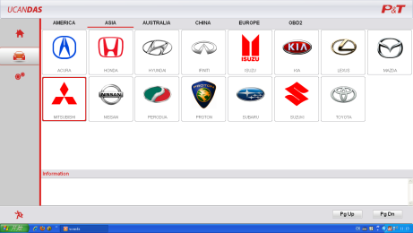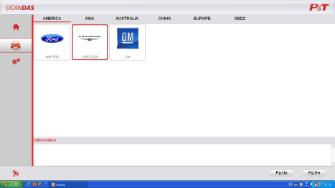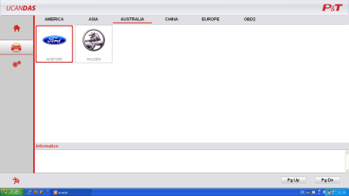

- Product functions Covered
Type | Region | Make
Vehicle make covered | AISA | ACURA, HONDA, TOYOTA, LEXUS, NISSAN, IFINITI, MITSUBISHI, SUBARU, SUZUKI, ISUZU, MAZDA, HYUNDAI, KIA, PROTON, PERODUA
Vehicle make covered | EUROPE | MERCEDES-BENZ, SAMRT, BMW, MINI, AUIO, VW, SKODA, SEAT, VOLVO, OPEL, VAUXHALL, PEUGOET, CITROEN, EURFORD, PORSCHE, JAGUAR, LANDROVER, FIAT, LANCIA, SAAB, RENAULT
Vehicle make covered | AMERICA | GM, AMFORD, CHRYSLER
Vehicle make covered | AUSTRALIA | AUSFORD, HOLDEN
Vehicle make covered | CHINESE | CHERY, GEELY, GWM
Vehicle make covered | OTHER | OBD-II
System Covered | ME-Motor electronics, CDI-Common Rail Diesel Injection, ETC-Electronic transmission control, ESM-Electronic selector module, SBC-Sensotronic Brake Control, ESP-Electronic stability program, BAS-Brake assist, Suspension, TPC-Tire pressure monitor, Airbag, CGW-Central gateway, EIS-Electronic ignition switch, OCP-Overhead control panel, UCP-Upper control panel, XALWA-Xenon headlamp, HRA-Headlamp range control, ATA-Anti-theft alarm system, IC-Instrument cluster, ASSYST-Active Service System, SCM-Steering column module, EPS-Electrical power steering, PTS-Parktronic system, EPB-Electric parking brake, COMAND/AUDIO, CD/DVD, TV tuner, CTEL-Cellular telephone, DCM-Door control module, ESA driver-Electric seat adjustment driver,ESA passenger-Electric seat adjustment passenger, AAC-Air conditioning, WSS-Weight sensor system, SVMCM-Special vehicle multifunction control module.
Function covered | Quick Test, Read ECU Info., Read DTCs, Erase DTCs, Clear learning value, Data Stream, Actuations, Read freeze frame data, Read/Write VIN, Basic Reset, Control unit adaptations, Throttle adaptations, Air bleeding, Level calibration, Theft alarm Reset, Key programming, Oil change, Idle speed learning, Idle speed Adjustment, Ignition timing adjustment, Camshaft timing control learning, Maintenance functions, ECU Initial startup, ECU initialization
Operating system | Windows XP, Windows 7, Windows 8
Language supported | English, Chinese(Simplified)

